IoT Based Health Monitoring in smart home system

Abstract:

The number of patients seeking treatment is always on the rise, while hospitals are providing treatment with specialized medical facilities and nursing staffs. With the advent of Internet of things and its applications patient can choose the place of treatment based on the convenience. By making use of advances in IoT, hospitals can provide patients with monitoring system for supervision without the need of separate medical expert for each patient. This work recommends a health monitoring system which has a vigilance on the emotion of the patient to detect pain through facial expressions while continuously checking for vitals in a cost effective manner. Although images are used for ensuring safety, a very little use of it has been found in the field of health monitoring.With images helping out medical experts to know the feelings of the patient providing them a more concentrated care in cost effective manner, IoT enabled embedded hardware based health monitoring system with camera interface is proposed and implemented in this work.A running prototype would be discussed through the entirety of this paper with insights on different modules.

Key Words:-Internet of Thing, Raspberry Pi, Emotion recognition, health monitoring.

Introduction:

In an ever growing technological world medical experts can make use of devices to continuously monitor the patients without being physically present by their side.

There may be people who may not afford a full-time service of a caretaker or a nurse .Which can lay the ground for technology to come to the rescue and provide a full-time surveillance of the patient and alert the caretaker or relatives whenever necessary .This way an elderly person who may live alone can be taken care or treated at home without spending much time at the hospital.

In the light of the above events a system must be present such that it identifies the patients vitals and stream the real time data to the caretaker or nurse and alert them when needed.Following the introduction is, to throw a limelight on the various concepts that are used in the prototype project developed and the components that are used before which some related work is shown.

Some systems already exists which where developed to detect the vitals of a patient using an low power microcontroller system such as arduino which combine a group of sensors to provide real time vitals monitoring of the patient[17][10].

And on the other hand emotion recognition model is generally run on a high end machine with high processing power.But the aim here would be to run on a embedded devices like Raspberry Pi .The Pi has a very low processing power compared to that of a high end machine but can be used as a full fledged computer.

Related work:

Emotions are the fundamental responses to external events that happen around us . Emotions include facial expressions,hand gestures and tone of voice which tells how a person feels and reacts, it is often intertwined with mood, temperament, personality, disposition, and motivation[4].Since the last decade many people have been experimenting on new ways and different sophisticated algorithms with image processing techniques to identify what an image or a video of a particular person[6] can say about his or her feelings[3] using machine learning techniques [5].Understanding these emotion presents a great deal of information on the persons present health status.

Researches have been trying to investigate and research techniques so that a machine can detect the way a person feels by these small gestures.While the take here is to map points onto a recognized face and based on calculations, provide output the feeling of a person with the input being the face of the patient.

According to Ekman & Friesen *facial behaviors are universally associated with particular emotions*[1]*.*All Humans develop similar kind of facial muscular features irrespective of their place of birth,color or race.Based on the above statements they classified emotions into six basic types which are (anger , fear , surprise , disgust , happy , sad)[9] .Through Machine learning(ML) the machine can be taught to detect emotions, from which we find whether a person feels pain.

The wheel below known as Russell’s circumplex model[9] which states that each emotion can be understood as a linear combination of these two dimensions, or as varying degrees of both valence and arousal.

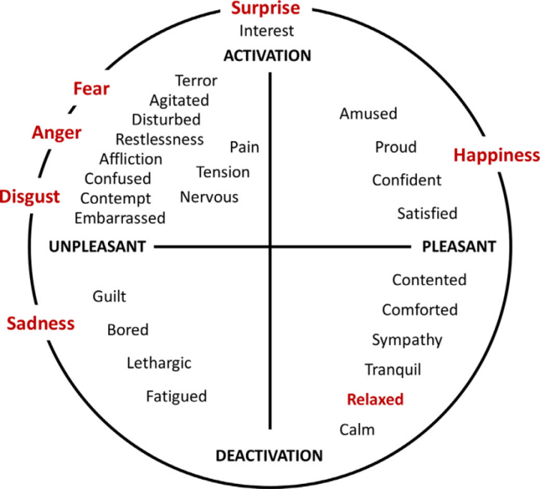

Fig-Russell’s Circumplex wheel describing basic emotions

The above circle shows the six basic emotions on the outer circle from which , we can identify the feelings that are present inside of it.

Experimental results have shown that finding happy and sad are way more easier that the rest, while fear and disgust being way more difficult[2].The implementation of different algorithms[12][13] are show in other papers, The results show SVM(Support Vector Machine) performing far more accurate than its peers[1][7].Leaving with modules that use SVM to detect the emotions.

Specially when the systems are installed at homes it may raise the issue of privacy but that camera can be made online or offline by turning them on or off and that does depends on the will and wish of the patient treated.

Since the last decade sensor have become a major part of life as they have been used every where lately in phones,cars,smart homes etc..These sensors come in handy where monitoring has to be done in real time[11].Which means sensors must be running quickly, smoothly while having a long life and when these sensors stop functioning properly the particular device is doomed by giving negative results causing a failure of the device[15].

With technology the medical field has seen a quite share of sensors for real time monitoring patients and their vitals.Sensors along with a controller(microprocessors or micro controllers) can perform special tasks and produce alerts when necessary. Every sensor has its own task which it performs in-turn to produce data.

A system in IoT must always have a cloud which stores and displays the data.Services as the above are provided by companies like IBM,Amazon etc giving developers a easy way to store and display them without much effort.Amazon web service IoT is one such service provided by amazon for establishing connections between the system and the cloud.

Methodology :

Moving into the working of the system,as discussed above can be split into three different working modules or elements which are 1)Sensor module 2)Emotion recognition module 3)Web service module.Combining the above separate working modules together creates the recommended system.

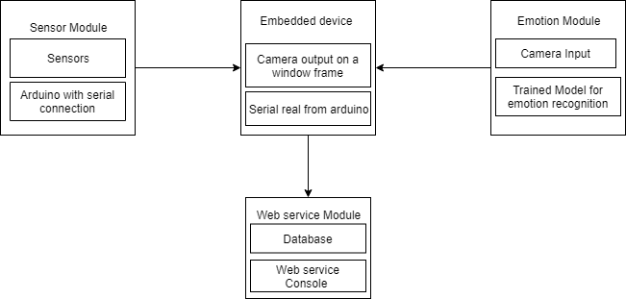

Fig.1.Overview of system block diagram.

1)Sensor module as the name suggests uses sensors to monitor the vitals of the patient in real time.The system uses arduino to act as a central unit to the sensors.Arduino is a

single board microcontroller which can be used to build digital devices or units which

 can sense and control objects in the physical and digital world.Purpose of choosing arduino here is because of its simplicity.low cost and is very easy to code.Sensors are devices which sense the surroundings to gain information of surrounding.As of writing there are diseases which many people are suffering from and every diseases has its way to recover from, which means all treatments need not have specific sensors[16].

The selection of sensors is purely based on the type of treatment which depends on diseases the patient has.The system provides details on some of the basic sensors that where used during prototyping the system[11].

For blood or saline monitoring we used an ultra sonic sensor mounted onto the top of the bottle with the face of the sensor towards the liquid inside the bottle, constantly giving the height of the liquid left[19] .Whenever the height goes down to value lower than the threshold the central unit arduino throws an alert.The arduino must be acquainted with the threshold for all the sensors to create the alert when needed.A temperature sensor was used to identify the body temperature of the patient.A live and running heart beat must always be there for life to be present, a pulse sensor was used to provides live heartbeats and BPM’s of the patient at all times.An IR sensor was used to check for any clumps during the transfusion.

The addition of additional sensors can be done just by import the libraries into and providing the threshold for the sensor

[16].

1. In related works above many theories on recognition of emotion and the six basic emotions have been discussed,so as to detect these emotions we used the emotion recognition module which has a picamera to take video input which is the patient’s face.Picamera is a 8-megapixel sensor and can capture video at about 90fps with a 1280*720 resolution.The raspberry pi is a low processing power system on chip computer.Providing user with a desktop like interface.The raspberry pi is used to display emotion on the monitor device connected to it.For that the pi must be on the same network as of the monitoring device.More on the working of the module will be discussed below.
2. Web service module acts as a display unit for the sensors data..Making use of the Amazon web services IoT interface the sensor data is relayed and displayed in the AWS console .A person with the authorization can view the data at all times which is relayed to the cloud[18].

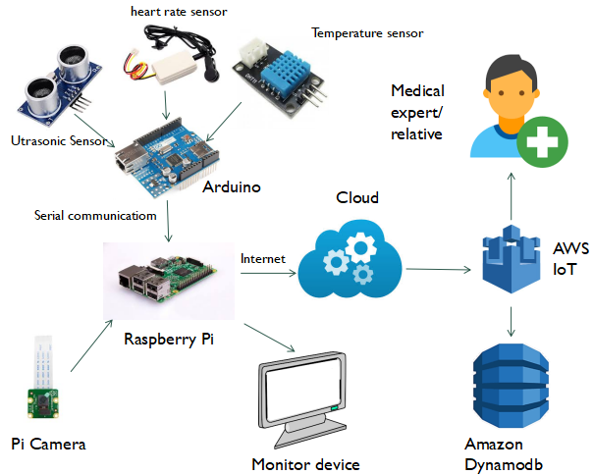+

Fig.2.System architecture

System Modules:

Given below is the sequence of steps on how the three module performed along with the workflow model in Fig 3.Sensor module with central unit arduino along with the list of sensors, the connections where made.Each sensor was connected to its designated pins along with connections to the voltage and the ground.All analog sensors are connected to the analog pins while digital ones on the digital pins of the arduino.The arduino must be coded to read sensors based on the type of sensor.After reading of data from the surroundings the arduino compares the data with the threshold displays on the serial monitor of the arduino.The task of sensor module is to relay real time data on the serial port so that raspberry pi can read it.

A series of steps takes place while finding the emotion of the inputted face of the patient.The capture of video was done by the picamera as mentioned above whose library was installed on the embedded device which its connected to the raspberry pi.

By reducing the frame rate a faster speed of detection was possible.The resolution of the camera was set to 640*480 for similar reasons.Having set u the hardware and needed inputs a python code was executed with all imported libraries[20] whose workflow is given below.

Before checking for the emotions of the patient a model was developed which is trained to read emotions based on the face.As given here [14] a python code is executed to train the model.The prerequisites for training the model is a dataset which has faces of peoples emotion from neutral with all the six basic emotions one after the other.The data sets like CK+,[FER-2013 Faces Database](http://www.socsci.ru.nl:8180/RaFD2/RaFD?p=main),RaFD[8] can be found online .For the system the FER database was used which has peoples faces, for each of the emotions that are (neutral,happy,sad,surprise,disgust,angry and fear).The training of the model took a lot of time, and training can be done on a personal computer not necessarily on the pi.After the training is completed the model was imported onto the pi and the path to the model given to the code that ran the below script.

The camera reads the input video and divides it into an array of frames,which are formed per the second.Each split frame of the video would be converted to a greyscale image where each pixel is represented by the amount of light ,that is, it carries only intensity information.After converting the image the most important part was to find the faces in each image.For finding faces a cascade classifier(XML file) was used which finds faces in the greyscale image and write it to a variable.The variable containing all the faces are resized for the model trained to take as an input.

The resized images of faces are sent to the model which predicts the possibility of each emotion and we select the emotion that has the highest possibility and display emotion for the person.This is done for for all the faces found in the frame.

Each frame was saved to the pirgbarray which is a buffer that holds the frame input.So before moving to the next frame the buffer should be cleared.

To display the results of each module a web service was used, for that a python code which establishes connection with Amazon web service was executed and data is pushed onto the server for display and storage.The procedure for connecting and displaying data was given by Amazon in its documentation on AWS IoT.

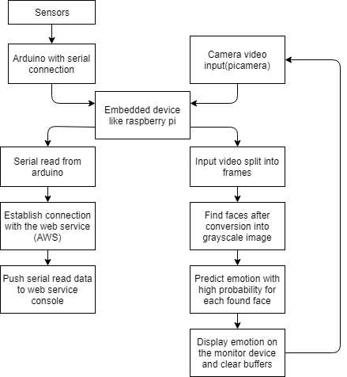

Fig.3.Workflow model of the system.

Results and discussion:

Given below are the images of each module related to the recommended system

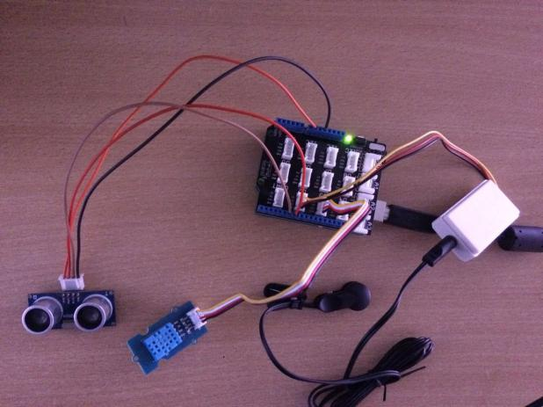 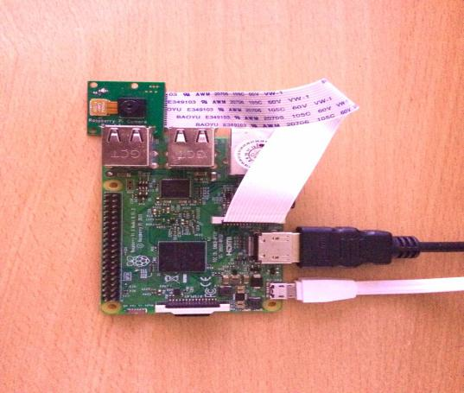

Fig .4.Sensor module Fig .5.Emotion recognition module

Fig 4 shows sensor module which has ultrasonic sensor(left most) temperature humidity sensor(bottom left) heart rate sensor(bottom right) and arduino (middle). Fig 5 shows raspberry pi connected with picamera.

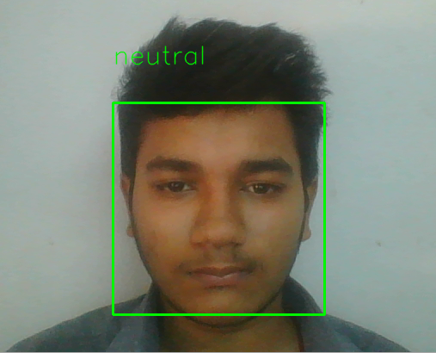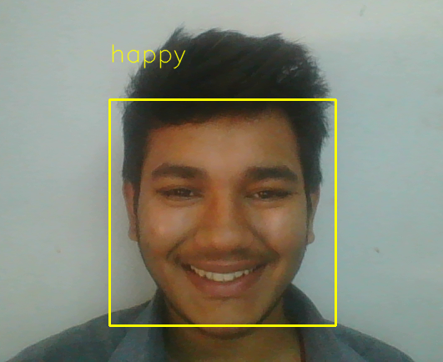

Fig .6. Fig.7.

The six basic emotions as discussed,with each image representing each of those emotions(Fig.6-11).

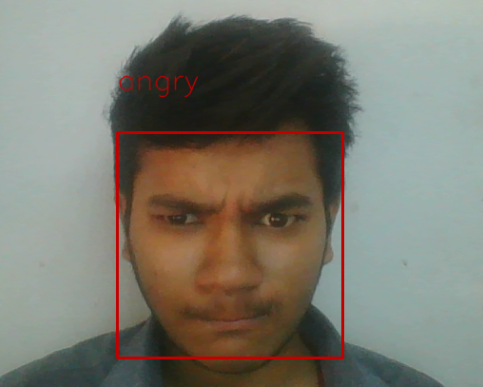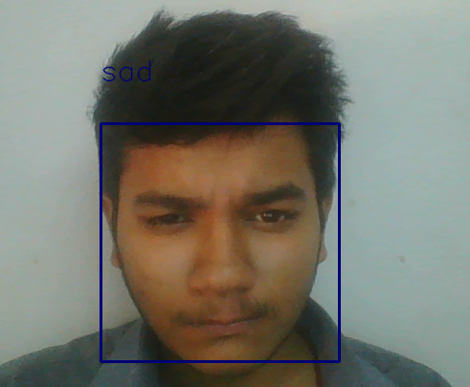

Fig.8. Fig.9.

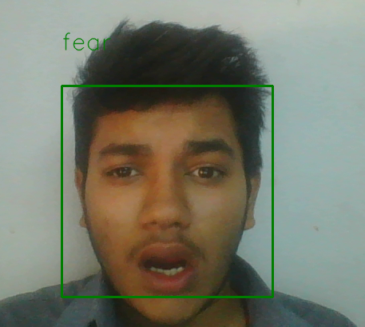 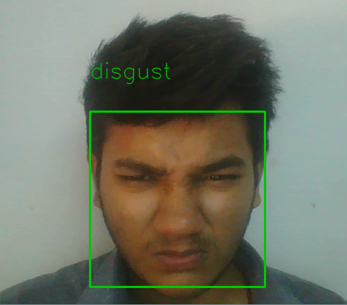

Fig.10. Fig.11.

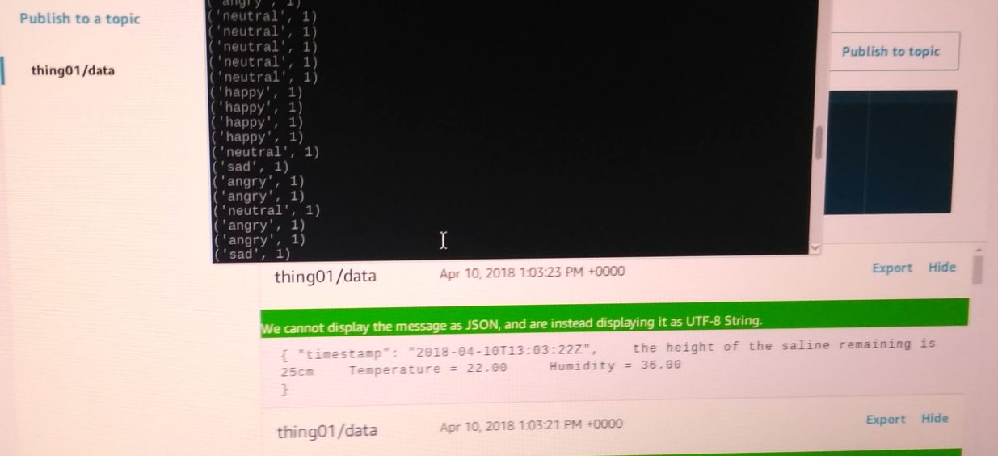

Fig.12.Results of sensor module on web service that is aws along with emotions relay on the monitor.

Conclusion:

The paper discussed the use of images and sensors to monitor the health of the patients who might be at home or hospital and offer them health care with IoT infrastructure.The system detects the face 99% of the time while giving the emotion of the person with around 70% accuracy.So each patient can have his or her own monitoring system which can be looked at by anyone with the authorization.While

sensors provide information of the patient vital and the emotion recognizer detects emotion, the care taker can predict pain if any based on the relay of the emotions detected.Future works could be to, implement a data mining concept that uses the emotion data to check for series of emotion for detecting pain.The advantages of the recommended system would be that both emotion recognizer and sensor module that works together and if one of them fails the other can take up the load of monitoring the patient until the failed unit is back and running.One of down side of the system would be a single point of failure that is raspberry pi where all the data is accumulated.While the data previously generated can be protected by using cloud database which is separated from the pi.Any corruption in the pi may lead to a system failure.As research grows there can be methods to increase accuracy and speed of the emotion recognize.The recommended system can be put together with a minimal cost of well under five thousand rupees that is around 70 dollars.

References:

[1] Leandro Y. Mano , Bruno S. Faiçal , Luis H.V. Nakamura , b , Pedro H. Gomes ,∗,Giampaolo L. Libralon , Rodolfo I. Meneguete , Geraldo P.R. Filho , Gabriel T. Giancristofaro , Gustavo Pessin , Bhaskar Krishnamachari , JóUeyama from Exploiting IoT technologies for enhancing Health Smart Homes through patient identification and emotion recognition.

[2]Paweł Tarnowski, Marcin Kołodziej, Andrzej Majkowski, Remigiusz J. Rak ,Emotion recognition using facial expressions.

[3]Giampaolo L. Libralon,Roseli A. F. Romero,Mapping of Facial Elements for Emotion Analysis.

[4]Ashwini Ann Varghese,Jacob P Cherian,Dr. Jubilant J Kizhakkethottam,Overview on Emotion Recognition System.

[5] T. Mitchell , Machine Learning, McGraw Hill, 1997 .

[6]Stan Z. Li ,Anil K. Jain ,Handbook of Face Recognition.

1. Husam Salih,Lalit kulkarni,Study of Video based Facial Expression and Emotions Recognition Methods.
2. P. Lucey , J.F. Cohn , et al. , The extended Cohn-Kanade dataset (CK+): a complete dataset for action unit and emotion-specified expression, in: IEEE Computer Society Conference on Computer Vision and Pattern Recognition Workshops.

[9]J. Russell , A circumplex model of affect, J. Personality Soc. Psychol.

[10]Himadri Nath Saha, Supratim Auddy, Subrata Pal, Shubham Kumar,Shivesh Pandey, Rocky Singh, Amrendra,Kumar Singh, Priyanshu Sharan, Debmalya Ghosh, Sanhita Saha,Health Monitoring and Management Using Internet-of-Things (IoT) Sensing with Cloud-Based Processing: Opportunities and Challenges.

[11]Pratiksha W. Digarse,Sanjaykumar L.Patil,Arduino UNO and GSM Based Wireless

Health Monitoring System for Patients.

[12]Andr´e Teixeira Lopes, Edilson de Aguiar, Alberto F De Souza, and Thiago

Oliveira-Santos. Facial expression recognition with Convolutional

Neural Networks.

[13]Mostafa Mohammadpour , Hossein Khaliliardali , Seyyed Mohammad R Hashemi, Mohammad . M AlyanNezhadi,Facial Emotion Recognition using Deep

Convolutional Networks

[14]Enrique Correa ,Arnoud Jonker ,Michael Ozo ,Rob Stolk,Emotion Recognition using

Deep Convolutional Neural Networks.

# [15]Dhiraj Sunehra,Pini Ramakrishna, Web based patient health monitoring system using Raspberry Pi.

[16]Mohan Lal Sahu, Jigyasu Kumar Kaushal Real time health monitoring system using Arduino and LabVIEW with GSM Technology.

[17]T.Saraswathi, S.Amutha, Iot Based Wireless Healthcare Monitoring.

[18]<http://www.fhilitski.com/2016/11/temperature-sensor-with-raspberry-pi-3-and-aws/>

[19]http://www.instructables.com/id/Measuring-water-level-with-ultrasonic-sensor/

[20]<https://www.pyimagesearch.com/2015/03/30/accessing-the-raspberry-pi-camera-with-opencv-and-python/>